**What's in a Name? Factors that influence the usage of Generic vs. Trade Names for Cardiac Medications among Healthcare Providers**

David Ouyang MD1, Rebecca Tisdale MD2, Paul Cheng MD PhD1, Jeffrey Chi MD2, Jonathan H. Chen MD PhD2,Euan Ashley MBBS PhD1,

1Department of Internal Medicine, Division of Cardiovascular Medicine, Stanford University School of Medicine, Stanford, CA USA

2Department of Internal Medicine, Division of Hospital Medicine, Stanford University School of Medicine, Stanford, CA USA

Word Count: 797

**Author Contributions:** Ouyang had full access to the data in the study and takes responsibility for the integrity of the data and the accuracy of the data analysis.

*Study concept and design*: Ouyang, Tisdale, Cheng

*Acquisition of data*: Ouyang, Chi, Chen.

*Analysis and interpretation of data*: Ouyang, Tisdale, Ashley, Chi, Chen.

*Drafting of the manuscript*: Ouyang, Tisdale, Cheng

*Critical revision of the manuscript for important intellectual content*: Ouyang, Tisdale, Cheng, Chi, Chen, Ashley

*Statistical analysis*: Ouyang, Tisdale, Chen.

**Introduction**

The use of trade names for drugs in clinical practice raises awareness of these brand names and has been shown to increase their use1. While academic medical centers have made an effort to teach generic medication names and discourage the use of trade names to reduce bias and contain costs, usage of trade names persists1-3. Text paging behaviors provide a reflection of real-world provider-to-provider communication outside of formal documentation. Applying a high-throughput method of assessing medication naming sentiment, we show that there is significant variability in preference of brand name versus generic name usage for common drugs. We sought to characterize the relative use of trade and generic drug names in text pages and associate these vernacular patterns with name and provider occupation characteristics.

**Methods:**

We analyzed 1,048,576 text pages to housestaff between June 1, 2013 and April 24, 2017 at an academic university hospital. Mentions of the most frequently used medications in cardiology were identified and tallied. When explicitly mentioned in the body of the text page, the profession of the sender was established. Common misspellings and alternative spellings were identified by regular expression and included in the analysis. Text pages were algorithmically processed using Python and analysis was performed in R and the packages ggplot2, ggthemes, scales, and plyr. Complete code for the data visualization is available at https://github.com/douyang/PagingDataAnalysis.

**Results and Data Visualization:**

We identified 102,243 pages regarding medications, of which 34,489 (33.7%) pages were from nurses and 20,446 (20.0%) pages were from pharmacists. Forty-seven commonly used cardiac medications were mentioned a total of 26,463 times. The most common classes of medications were anti-arrhythmics (14.6%), angiotensin-converting-enzyme inhibitors (14.6%), and beta blockers (12.5%). There was significant variation in the preferential use of brand names vs. generic names (Figure 1).

We created a two-part data visualization to display the variation in the use of generic and brand names for medications across subspecialties, medication classes, provider types, and the frequency of mention. On the left hand side of the figure is a plot of the ratio of generic to brand name usage for each medication in a manner similar to forest plots in meta-analyses. This visually demonstrates the variation in the use of each name. At the center of the figure, a ratio of 1 suggests equal use of generic and brand names. Medications to the left of the center of the figure have a ratio less than 1, suggesting more generic name mentions than brand name, while medications to the right of the center of the figure have more brand name mentions than generic name mentions. The left side of the figure is labeled with the generic name and the right side of figure is labeled with the brand name, and points closer to each side suggest more frequent use of the each name. A point and 95% confidence interval line is used to represent all mentions, while mentions that can be attributed to either a pharmacist or a nurse are independently analyzed and the ratio denoted by a P or a N respectively. On the far right side of figure is a histogram of total mentions of each medication.

Walking through an example medication, furosemide or Lasix is the last medication in our figure. From the right side, we see that this is a commonly mentioned medication, with almost five thousand mentions in our dataset. From the total of 4,985 mentions, the ratio of mentions for "Lasix" to "furosemide" is 17.4, so the point estimate is on the right side of the figure. Of the subset of pages from nurses and pharmacists, the ratios are 42.5 and 3 and the point estimates denoted by "N" or "P" are respectively to the right and left. From this figure, we see that there is significant variation across specialties, medication classes, and provider types for the use of generic and brand names. Nurses are more likely to use trade names than pharmacists (p = 0.02). Physicians do not usually self-identify their role in the text page, thus we were unable to independently assess their behavior.

**Conclusions**

Unnecessary use of brand name drugs has been linked to decreased patient compliance and worse health outcomes4. Failure to substitute brand-name for generic drugs has been estimated to result in billions of dollars in excess costs to individual patients and the US health system yearly4. Despite these harms, usage of trade names persists in the clinical setting. Familiarity with brand names has been shown to contribute to their use, and in our study, we use a high throughput method of analyzing and visualizing provider sentiment. To the extent that text pages do reflect other modes of communication (e.g. documentation in the clinic record), the patterns of brand name use demonstrated in our figure suggest that interventions to promote the use of generic names and limit bias in medicine are needed.

Figure 1

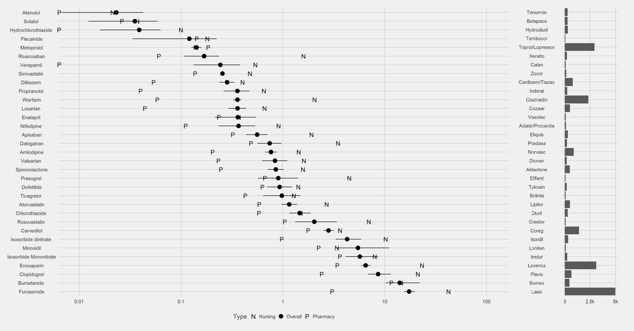

Bibliography

1. Mott DA, Cline RR. Exploring generic drug use behavior: the role of prescribers and pharmacists in the opportunity for generic drug use and generic substitution. *Med Care*. 2002;40(8):662-674. doi:10.1097/01.MLR.0000020926.85284.8E.

2. Sierles FS, Brodkey AC, Cleary LM, et al. Medical students’ exposure to and attitudes about drug company interactions: a national survey. *JAMA*. 2005;294(9):1034-1042. doi:10.1001/jama.294.9.1034.

3. Austad KE, Avorn J, Franklin JM, Campbell EG, Kesselheim AS. Association of marketing interactions with medical trainees’ knowledge about evidence-based prescribing: results from a national survey. *JAMA Intern Med*. 2014;174(8):1283-1290. doi:10.1001/jamainternmed.2014.2202.

4. Choudhry NK, Denberg TD, Qaseem A. Improving adherence to therapy and clinical outcomes while containing costs: opportunities from the greater use of generic medications: best practice advice from the Clinical Guidelines Committee of the American College of Physicians. *Ann Intern Med*. 2016;164:41–49. doi: 10.7326/M14-2427